Student: Jiwon Jung
Course: MSCS-632
Input: Schedule prefer
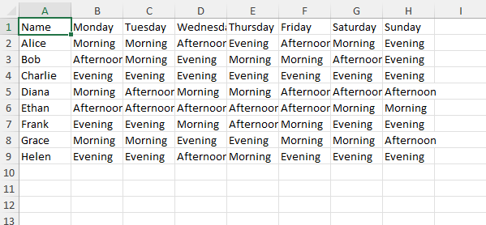

Output: Final Schedule (Aligned manually after get the file)
